# Results

## Relationship across the hypothetical environmental gradient

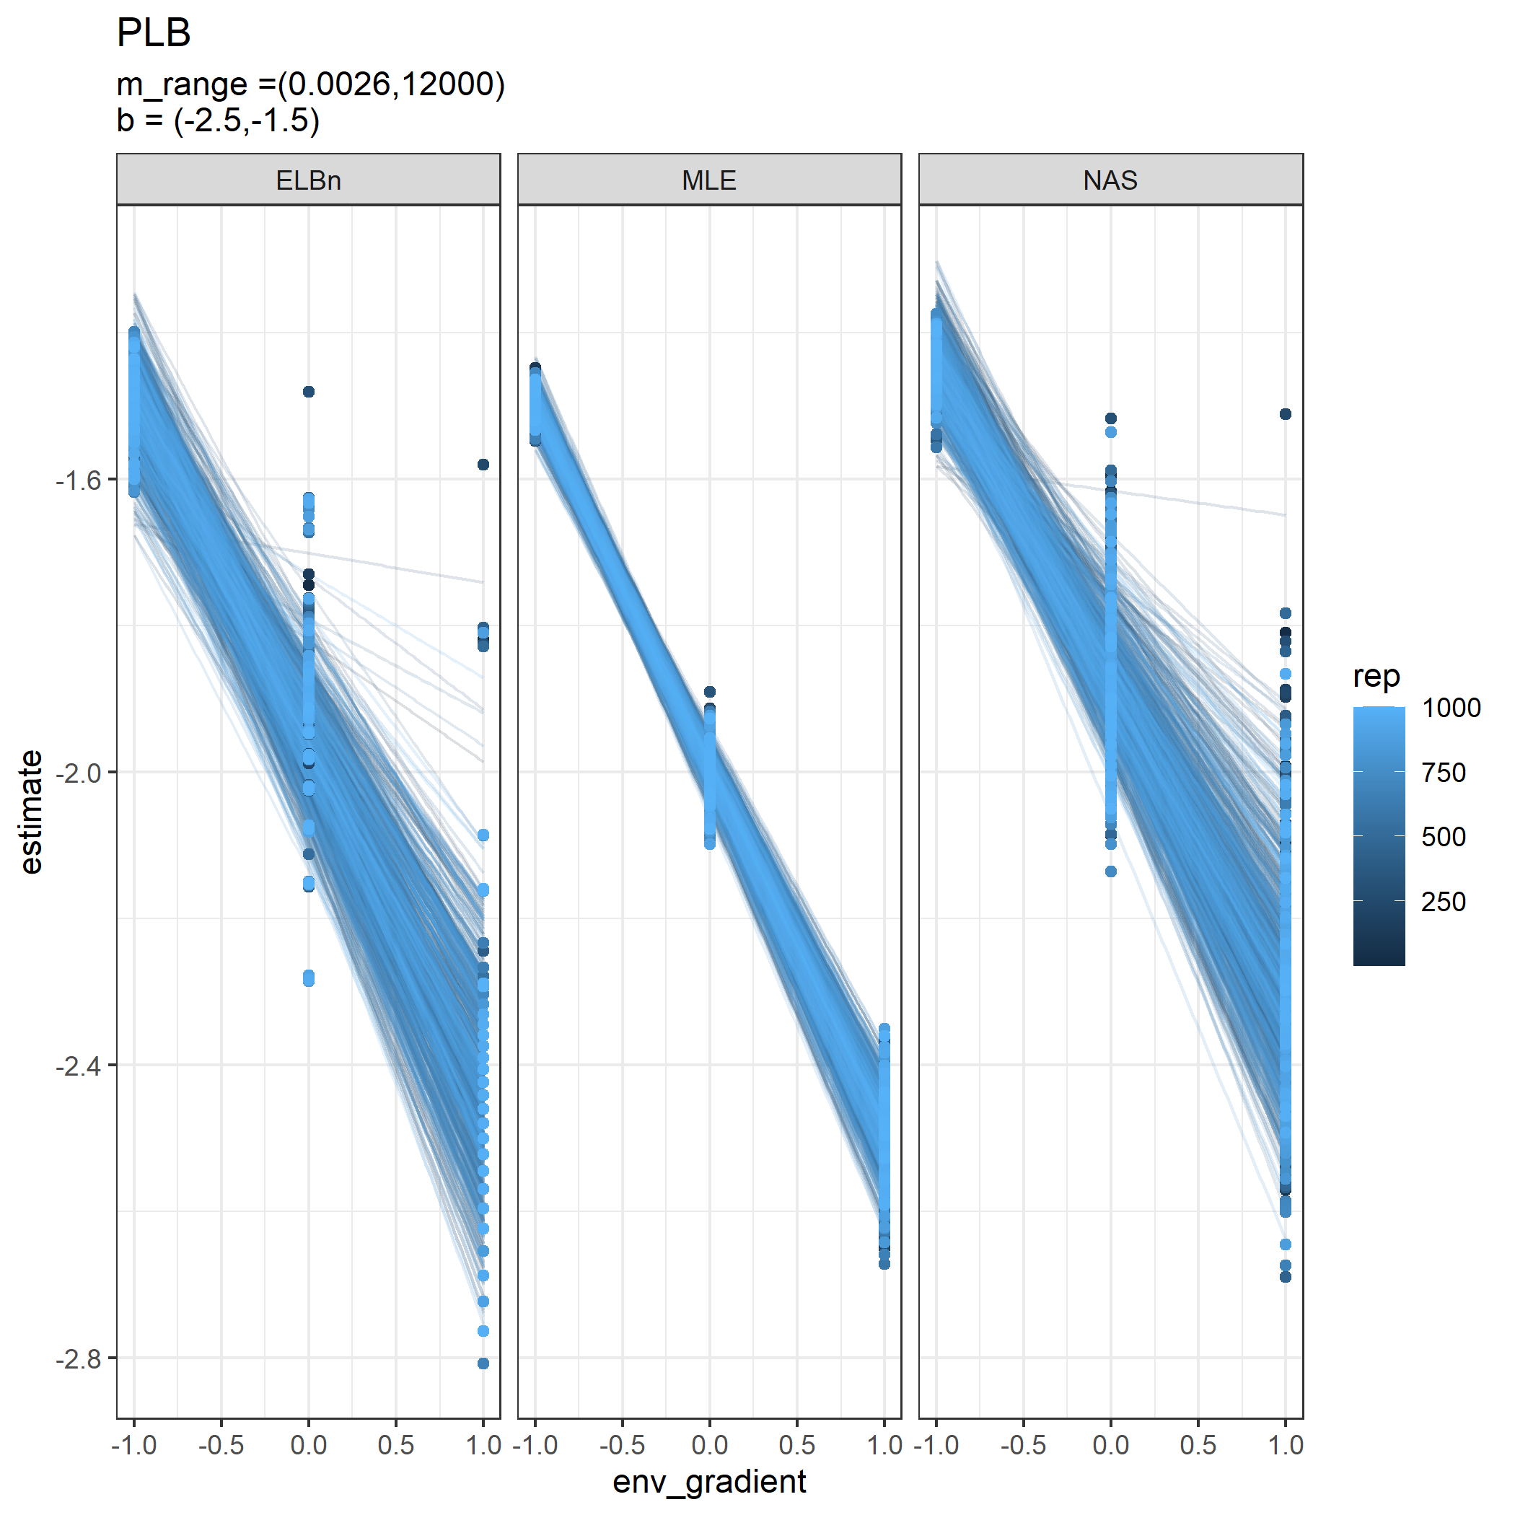

Relationship estimates across the hypothetical gradient for each replicate. Each panel is a different method for estimating the size spectra parameter.

All methods performed reasonably well in detecting the known relationship across the hypothetical environmental gradient. The regressions using the MLE method found a significant relationship 100% of the time, while the ELBn and NAS method found significant relatoinships 95.8% and 96.9% of the time, respectively.

The confidence intervals for the relationship coefficients ($β_{1}$) for both the MLE and ELBn method contained the true value of the known relationship across the gradient $≥$ 95% of the time, whereas the confidence interval for the NAS method only had the true value 83.1% of the time. Despite having similar accuracy, the width of the CIs for the ELBn method were more than 3 times that of the MLE method (ELBn_CI_ = 0.386 $±$ 0.20; MLE_CI_ = 0.121 $±$ 0.056). The CI’s for the NAS were slightly smaller than the ELBn method, but still $>$ 2.5 times as wide as the MLE method (NAS_CI = 0.339 $±$ 0.172).

On average, the relationship across the gradient was under estimated: MLE -0.002 ( $±$ 0.022); ELBn -0.039 ( $±$ 0.062); and NA -0.081 ( $±$ 0.061).

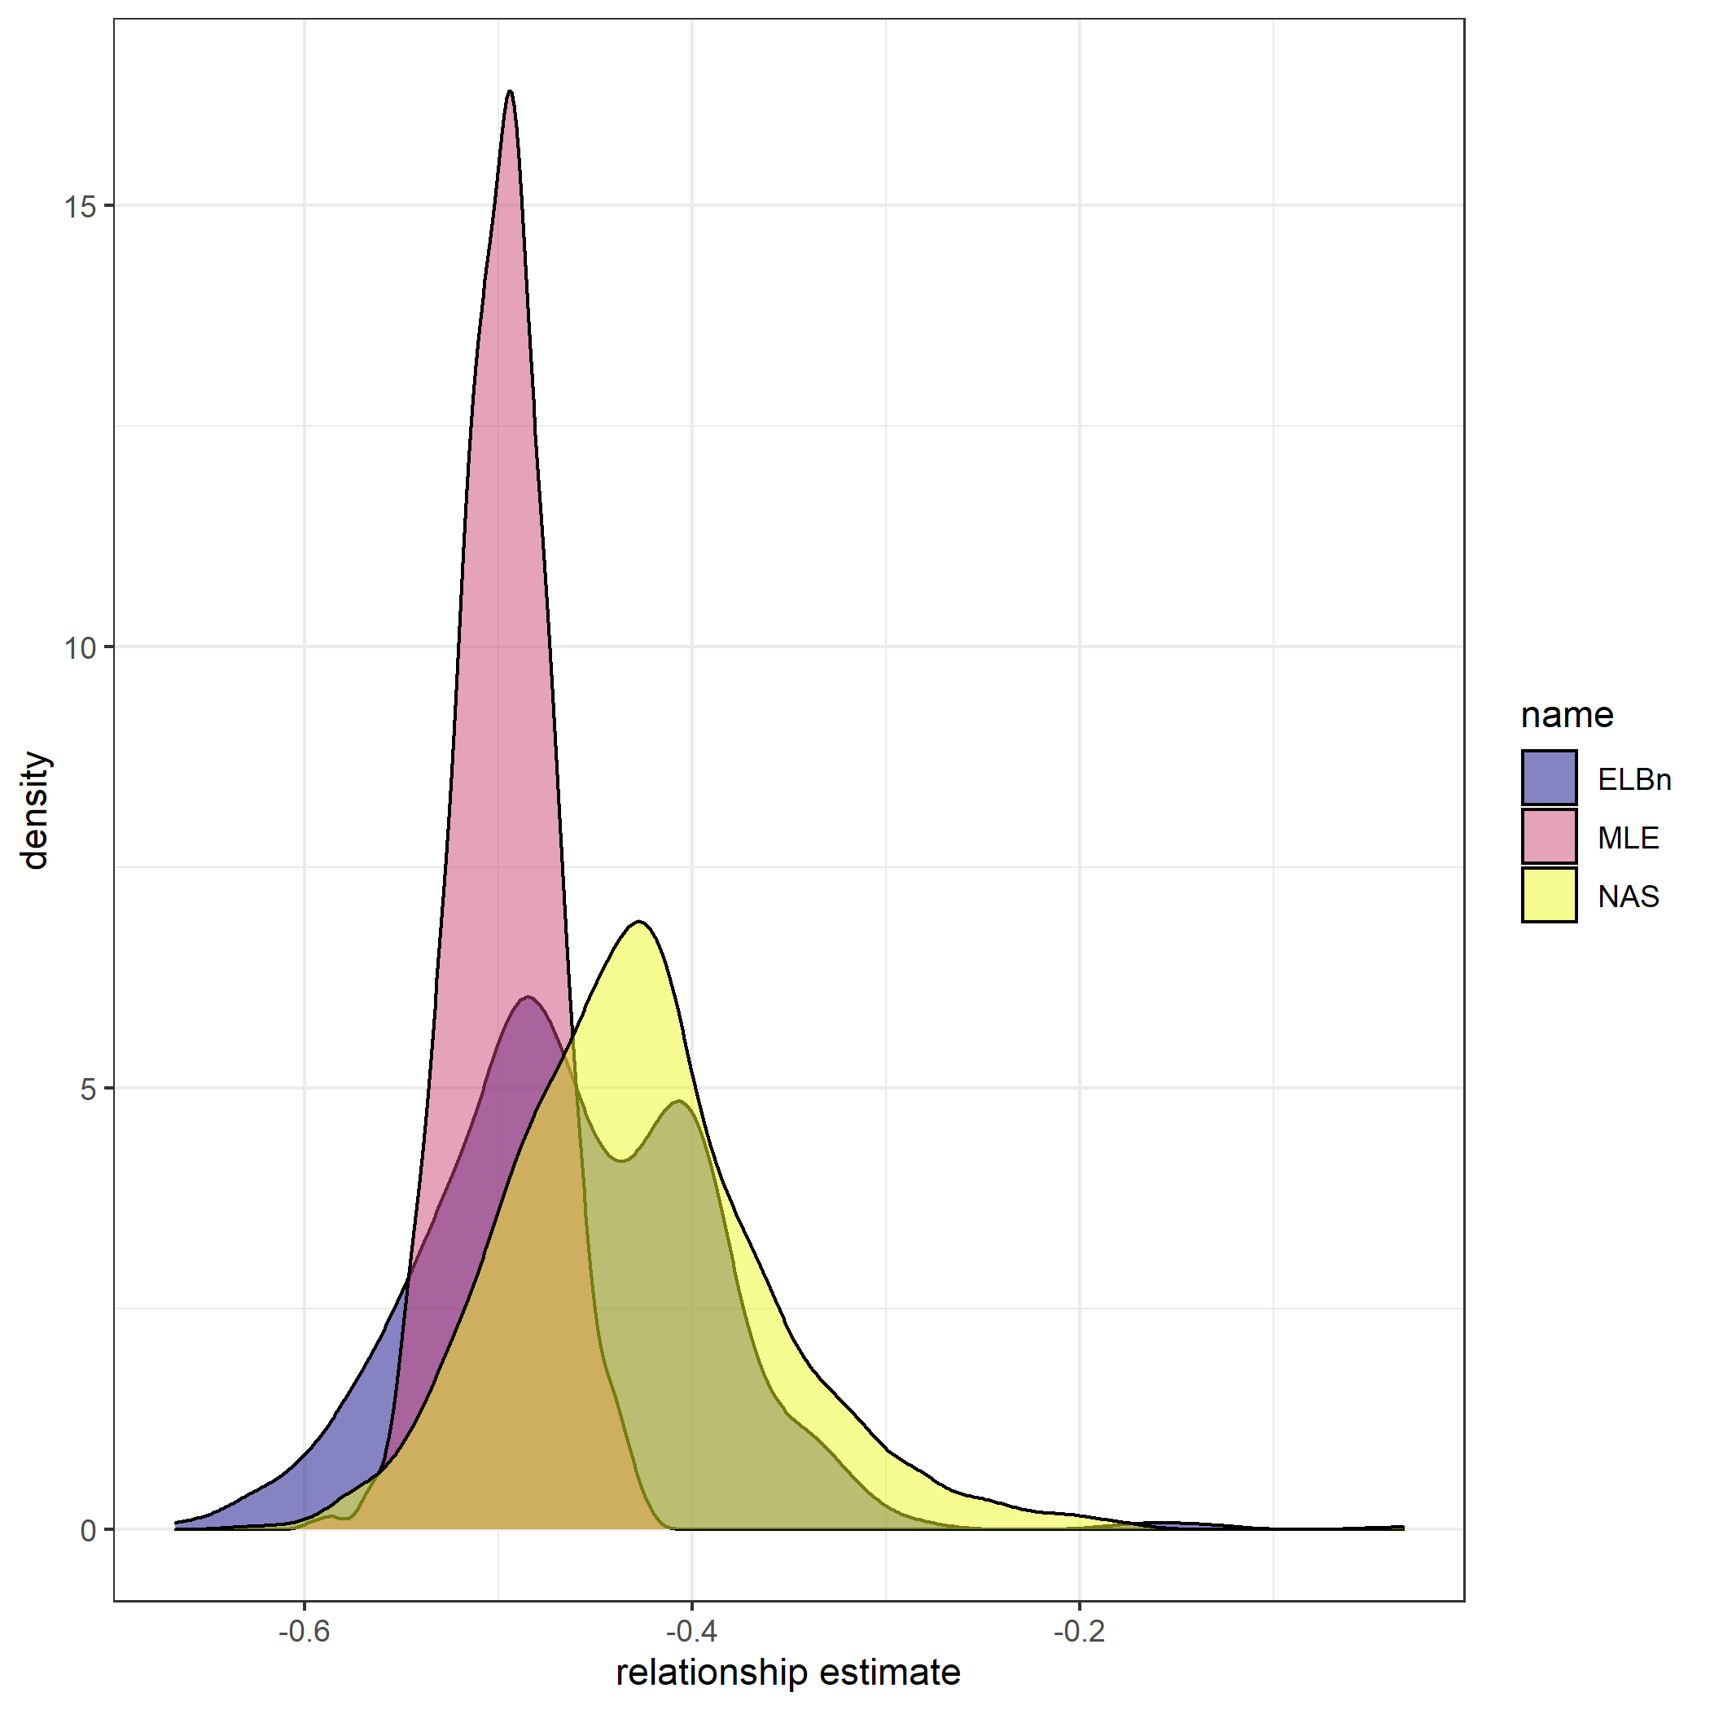

Distribution of relationship coefficient estimates. Vertical line is the known relationship. All methods under estimate the value, but the mean magnitude and distribution of values is greater for the ELBn and NAS methods.

Interestingly, there was an interactive effect of the estimate accuracy between sample size and the value of $λ$. All methods were more accurate with larger sample sizes, and smaller values of $λ$.

Distribution of size spectra parameter estimates. Vertical line is the known parameter wich describes the bounded power law distribution from which the body size estimates were sampled. As n increases (top to bottom) and $λ$ increases (left to right), the accuracy of the estimate improves across all methods.

Individual regression estimates across the hypothetical gradient based on sample size (rows) and methodology used (columns).

## No relationship

All of the methods performed similarly when there was no relationship across the hypothetical gradient. The Type I error rate for MLE, ELBn and NAS were 5%, 5.7% and 4.6%, respectively. However, the confidence intervals for the binning methods were ~3 times as wide as the MLE method (mean CI widths: MLE = 0.116, ELBn = 0.372; NAS = 0.332).

Of the relationships which were estimated to be significant, the MLE, ELBn, and NAS method had a 58%, 49.1% and 54.3% probability of indicating a negative relationship, respectively.

Individual regression estimates when no relationship exists across the hypothetical environmental gradient. The methods are separated by rows, and the left and right column show relationships which were non-significant and significant, respectively. The individual regressions coefficients are colored-coded to indicate positive and negative relationship estimates.

## Small variation in lambda

The performance of all methods declined when trying to detect variation in the $λ$ parameter between -1.9 to -2.1 across the environmental gradient. The mean $β_{1}$ coefficient estimates for all methods were closely associated with the known relationship. Once again the variation in the estimates using the MLE method were much smaller that the estimates using both of the binning methods (Figure 4).

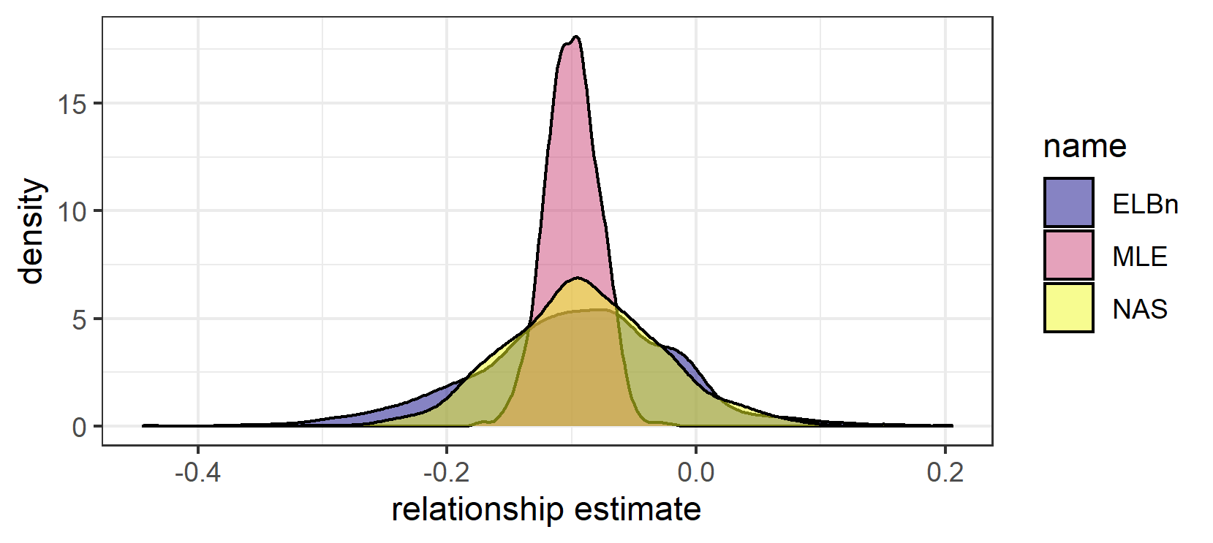

Mean difference between relationship estimate and known relationship coefficient for each method. Here, $λ$ varied from -1.9 to -2.1, with a kown relationaship of -0.1 across the gradient.

Of the 1000 simulation replicates, the MLE only detected a significant relationship 90% of the time, whereas the ELBn and NAS methods detected significant relationships 19 and 23% of the time, respectively. Of the replicates which were significant, the confidence interval contained the true value of the relationship 94.6, 88.4, and 89.1% of the time for the MLE, ELBn, and NAS methods, respectively.

Linear regressions across the hypothetical gradient when lambda varies from -1.9 to -2.1. Each method is displayed in the rows, and the left colum shows the non-significant estimates, while the right column shows the relationships which were signficant ( $β_{1}$ coefficient p-value < 0.05). The colors indicate when the beta coefficient estimate was negative (pink) and when it was positive (purple).

Once again, the width of the confidence intervals for both of the binning methods were $≥$ 2.8 times that of the MLE method (mean $±$ SD MLE CI width: 0.117 $±$ 0.051; ELBn CI width: 0.378 $±$ 0.169; NAS CI width: 0.332 $±$ 0.150).

On average, the relationship estimates across the gradient were similar to the know value (mean deviation: MLE = 0.00001, ELBn = -0.009, NAS = -0.012). However, when only looking at the relationships which were significant, this variation increased considerably(MLE = -0.002, ELBN = -0.052, NAS = 0.034).

## Empirical data

For both empirical datasets, the direction and magnitude of chnage (i.e. $β_{1}$  coefficients) are generally in agreement. Size spectra parameters consistently increase (become flatter) in the AMD data (Fig. XX A). Likewise, the size spectra parameters consistently increase (become steeper) with increasing temperature across the NEON sites (Fig XX D)

**NOTE** combine all the figures below into one with 4 panels (AMD = A, B; NEON = C, D)

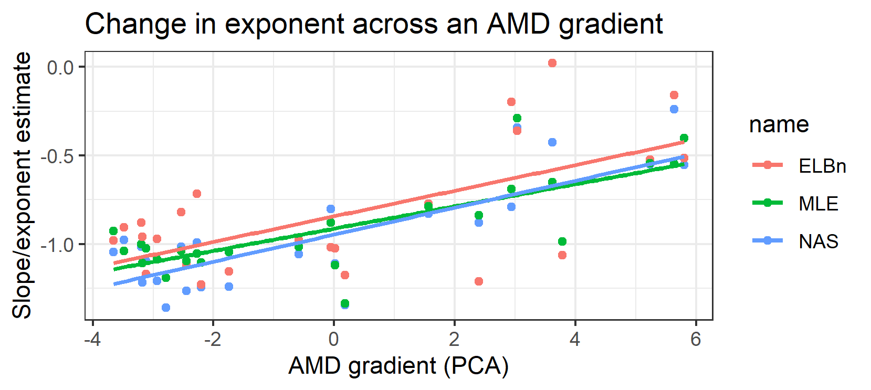

A

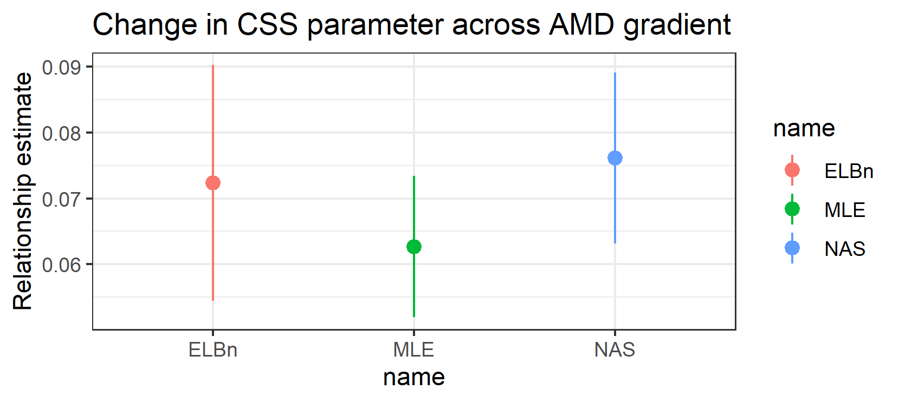

B.Relationship estimates across AMD gradient

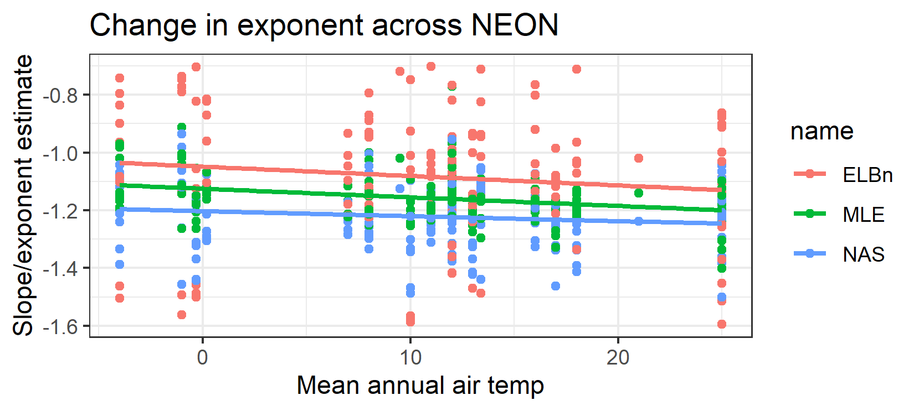

C.

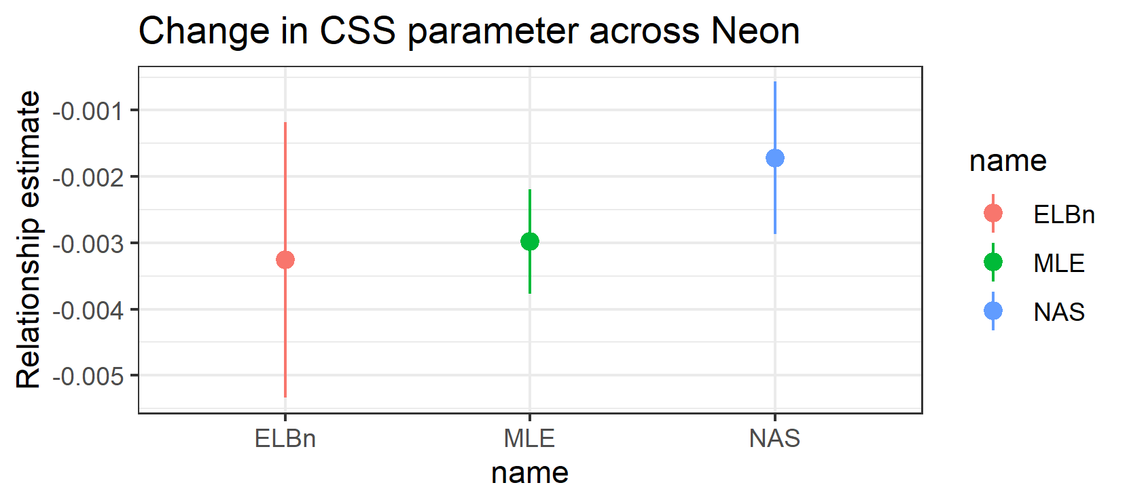

D.

Because the $β_{1}$ coefficient estimates are similar, and the range of the gradient in the AMD data is relatively small (9.5), the absolute change in the size spectra parameter across the AMD gradient are similar regardless of method used (range: 0.59 to 0.72). Likewise, the absolute change in size spectra parameters across the NEON temperature gradient ranges from 0.06 to 0.165, depending on the method used.

*alternative* absolute difference of ~0.1 units in $λ$ across gradients is similar to differences reported in other studies (seasonally: 0.16, Mcgarvey and Kirk; landuse: 0.15 Martinez; O’Gorman 2017 ~0.25, Yvon and Dossena papers ~0.1? [need to redownload some of these and compare])(Dossena et al. 2012, O’Gorman et al. 2017, McGarvey and Kirk 2018)

## Simulating shallower lambdas

Estimates of the relationship between lambda and a hypothetical gradient varied depending on the method used. However, interpretations of empirical data were broadly consistent across methodologies. Upon closer inspection, the values of size spectra parameters in the empirical data were considerably shallower than -2. Given that we found the performance of all methods increased with shallower $λ$’s we wanted to investigate how the methods performed with simulated values more similar to the empirical estimates of parameters describing size spectra relationships. Therefore, we repeated the simulation process as in the main analysis, but used $λ$ values ranging from -1.1 to -1.5.

Relationship estimates across the hypothetical gradient for each replicate. Each panel is a different method for estimating the size spectra parameter.

We found generally less variability in the relationship estimates across a gradient of distributions described with shallower $λ$ parameters. All of the relationship coefficient estimates ($β_{1}$)’s across all replicates were significant regardless of method used. The confidence interval for $β_{1}$ estimate for the MLE method contained the true value 94.7% of the time. However, the true value was in the confidence interval for the ELBN and NAS method only 90.9% and 76.9% of the time, respectively. Once again, the mean width of the CI for the binning methods were ~2 times as large as for the MLE method. Mean $±$ SD CI width: MLE = 0.0442 $±$ 0.0196; ELBn = 0.0920 $±$ 0.0482, NAS = 0.0798 $±$ 0.0324.

On average, the relationship across the gradient was under estimated, but by nearly an order of magnitude less than when simulating across steeper values of $λ$. Differences between known and estimated relationship coefficients: MLE -0.0007 ( $±$ 0.0079); ELBn -0.0058 ( $±$ 0.0177); NAS -0.0251 ( $±$ 0.0124).

Distribution of relationship coefficient estimates. Vertical line is the known relationship. All methods under estimate the value, but the mean magnitude and distribution of values is greater for the ELBn and NAS methods.